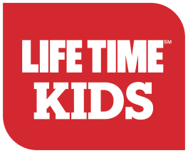

Community Parents Night Out
Allow your child ages 4-12 join other local community school and Life Time members for a night of
rock climbing, swimming, gym games, sports, bounce house and more. Students should bring, gym shoes and comfortable clothes. A pizza dinner from our Life Café will be provided.
Life Time will keep your kids healthy and happy, while parents enjoy a night out AND raise valuable funds
For Brummer Elementary

For every child that registers and attends Parents Night Out, Life Time will donate $5 to Brummer Elementary. These nights are typically open to members only; however this event is open to selective community schools and their students.
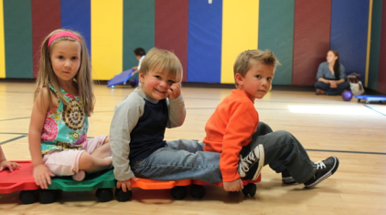
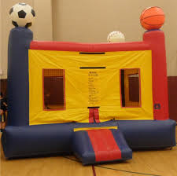
Friday, December 22nd 2017
6:00 p.m. – 10:00 p.m.
Life Time Fitness Novi
40000 High Pointe Blvd
Novi, MI 48375
Fee: $25 1st child and $20 each additional in the same family.
REGISTRATION DEADLINE: Tuesday, December 19th 2017
For more information, please contact Life Time Fitness Novi at:
(248)735-5351 or Rbarndt@lt.life
ENROLL TODAY - SPACE IS LIMITED
SCHOOL NAME: __________________________________ EMAIL*:_______________________________
CHILD'S NAME:_________________________________CHILD'S BIRTHDATE:_______________________
CHILD'S NAME:_________________________________CHILD'S BIRTHDATE:_______________________
PARENTS NAME:__________________________________ PHONE #_____________________________
ADDRESS:_______________________________________________________________
PLEASE MAKE PAYMENTS payable to Brummer PTO PAYMENT REQUIRED FOR REGISTRATION. * A valid email address is required for registration. Additional paperwork will be required to complete the registration process. This paperwork will be emailed to the email address that is provided.

