Brummer Elementary
Schools Out Camp
Allow your child ages 4-12 to join other school students for a day of
rock climbing, gym games, swimming, sports, crafts and more. Students should bring: gym shoes, swimsuit, towel, comfortable clothes and lunch. (A hot lunch may be purchased for $5.00)

Life Time will keep your kids healthy and happy, and having fun while raising funds for
Brummer Elementary.

For every child that registers, Life Time will donate $8 per day to Brummer Elementary. These days are typically open to members only; however we want to make Life Time a Healthy destination for the community.

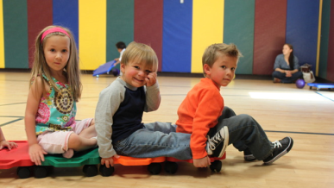
January 15th
8:00 a.m. – 6:00 p.m.
Life Time Fitness Novi
40000 High Pointe Blvd
Novi, MI 48375
Fee: $48 per day 1st child and $45 each additional
REGISTRATION DEADLINE: Thursday, January 11th
For more information, please contact Life Time Fitness Novi at:
(248)735-5351 or Rbarndt@lt.life
ENROLL TODAY - SPACE IS LIMITED
SCHOOL NAME: __________________________________ EMAIL*:_______________________________
CHILD'S NAME:_________________________________CHILD'S BIRTHDATE:_______________________
CHILD'S NAME:_________________________________CHILD'S BIRTHDATE:_______________________
PARENTS NAME:__________________________________ PHONE #_____________________________
ADDRESS:________________________________________
PLEASE MAKE PAYMENTS payable to Brummer PTO (PAYMENT REQUIRED FOR REGISTRATION) and return to the Office. * A valid email address is required for registration. Additional paperwork will be required to complete the registration process. This paperwork will be emailed to the email address that is provided.

